Copyright Transfer and Statement of Originality

Corresponding author : Hanim Nur Faizah .

Manuscript title : CHANGES IN LONELINESS FOLLOWING COMBINED LAUGHTER AND

BUTTERFLY HUG THERAPY AMONG ADOLESCENTS IN ISLAMIC BOARDING SCHOOLS

Affiliation : INSTITUT ILMU KESEHATAN NAHDLATUL

Laboratory/department/institution Nursing Study Program, Faculty of Nursing and Midwifery,

Institut Ilmu Kesehatan Nahdlatul Ulama Tuban

Correspondence address

(any change in correspondence address, please inform us)

Mail Address : Institut Ilmu Kesehatan Nahdlatul Ulama Tuban, Jl. KH. Hasyim Asyhari No. 26, Tuban, East Java, Indonesia

Phone/ Mobile Phone Number, : 081216725105

Email Address : Hanimfaizah.stikesnu@gmail.com

STATEMENT

I, the corresponding author, declare that the following matters of submission on the above original paper are correct (please do not circle any)
- This manuscript is our original work and free from plagiarism content.
- This manuscript has not been published before and is not currently being considered for publication elsewhere.
- Name of supervisor/s is put in the author list as co-author/s If the manuscript is part of a bachelor’s or master’s thesis or internship report.
- Name of student/s is put in the author list as co-author/s If they made a contribution to the study/ manuscript writing.
- Name of colleague/s or research team member/s is put in the author list as co-author/s if the made a contribution to the study/ manuscript writing. If there are any authorship disputes, it will be resolved internally.
- The manuscript has been approved by all authors for publication (if there are more than one author)

By signing below, I certify all information is true and correct to the best of my knowledge

1 October 2026

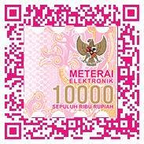
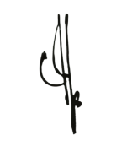
Corresponding author

(Hanim Nur Faizah)

